Yield Curve Monitoring for Base Benefit Rates
Project Brief

1. Background
Thames Valley Financial Inc. (TVFI) is launching a new retirement product, Secured Retirement, that provides guaranteed income for life in retirement. Like a defined benefit pension plan, employees pay into the plan throughout their career and retire with guaranteed income for life. However, the mechanics behind Secured Retirement are different from a defined benefit pension plan. Secured Retirement operates by allowing people to purchase small “pieces” of guaranteed income with every paycheque. The amount of income purchased beginning at age 65 for every dollar of contribution is called the benefit rate. The rates vary based on a variety of factors (e.g., age, sex) and are quoted by TVFI using several economic and non-economic assumptions that can change over time. Thus, the benefit rates are dynamic. (Contributions made under past benefit rates are locked in. Only future benefit rates can be changed.)
We need to develop a methodology for adjusting the benefit rates based on economic and non-economic assumptions. One assumption that can change regularly (and has a big impact on benefit rates) is the interest rate assumption, which will be the focus of this project. Our interest rate assumption is based on several inputs that update at different frequencies: a Canadian public yield curve that is available daily, a reference curve sourced from Fiera that is published monthly, and an insurer-specific parameterization to reflect their specific portfolio composition (largely static). We need to have the flexibility to reprice our benefit rates up to daily in accordance with updated interest rate assumptions. Thus, we need a monitoring framework in place that will compare the current interest rate environment to the basis used to price the current benefit rates. We need to be able to assess the profitability of the product using the current benefit rates under the new assumptions and determine if a repricing of the benefit rates is necessary.

2. Project Objective
Design and build a working operational process for monitoring current interest rates: a way to source daily yield curve data, create an implied assumption using the updated data, Fiera curve, and static parameters, compare to the pricing basis, and determine if changes in these curves are significant enough to warrant repricing the base benefit rates. The operational process must withstand the scrutiny of OSFI, the federal regulator for financial services (banking, insurance, pensions).

3. Problem Statement
Several parts of this project involve open questions, without a specific correct answer. Part of the project is developing a process that you think is sensible and arguing why you think that.
- Data sourcing: We need a reputable, reliable source for daily yield curves. What source(s) give a usable daily Canadian public yield curve?
- Fiera curve gap: Fiera’s curve is only observed monthly. What is a defensible way to infer, on any given day, what Fiera’s curve would say if it updated more often? Is it necessary to make this inference or is using the most recent curve a reasonable choice?
- Trigger definition: Our existing framework triggers on curve movement beyond a threshold, but it’s still to be determined exactly what “movement beyond a threshold” should mean (e.g., a parallel-shift rule, a duration-weighted measure, a shape/twist test, or some combination). Provide a recommendation and defend it.
- Slope software interaction: Slope software is our actuarial modeling system, and we can interact with our models using their API. This is implemented in Python. We need to be able to input data to Slope for modeling and extract model outputs to then package into reporting results. We cannot provide direct access to our Slope models, but we will provide a dummy version of Slope to help you test your code. We will facilitate testing your code using the real model, possibly at defined checkpoints (still to be determined).

4. Process Overview
The diagram below shows how the pieces fit together: the baseline curves that produced today’s rates, the daily monitoring loop, the trigger decision, and the profitability comparison that follows if the trigger fires.
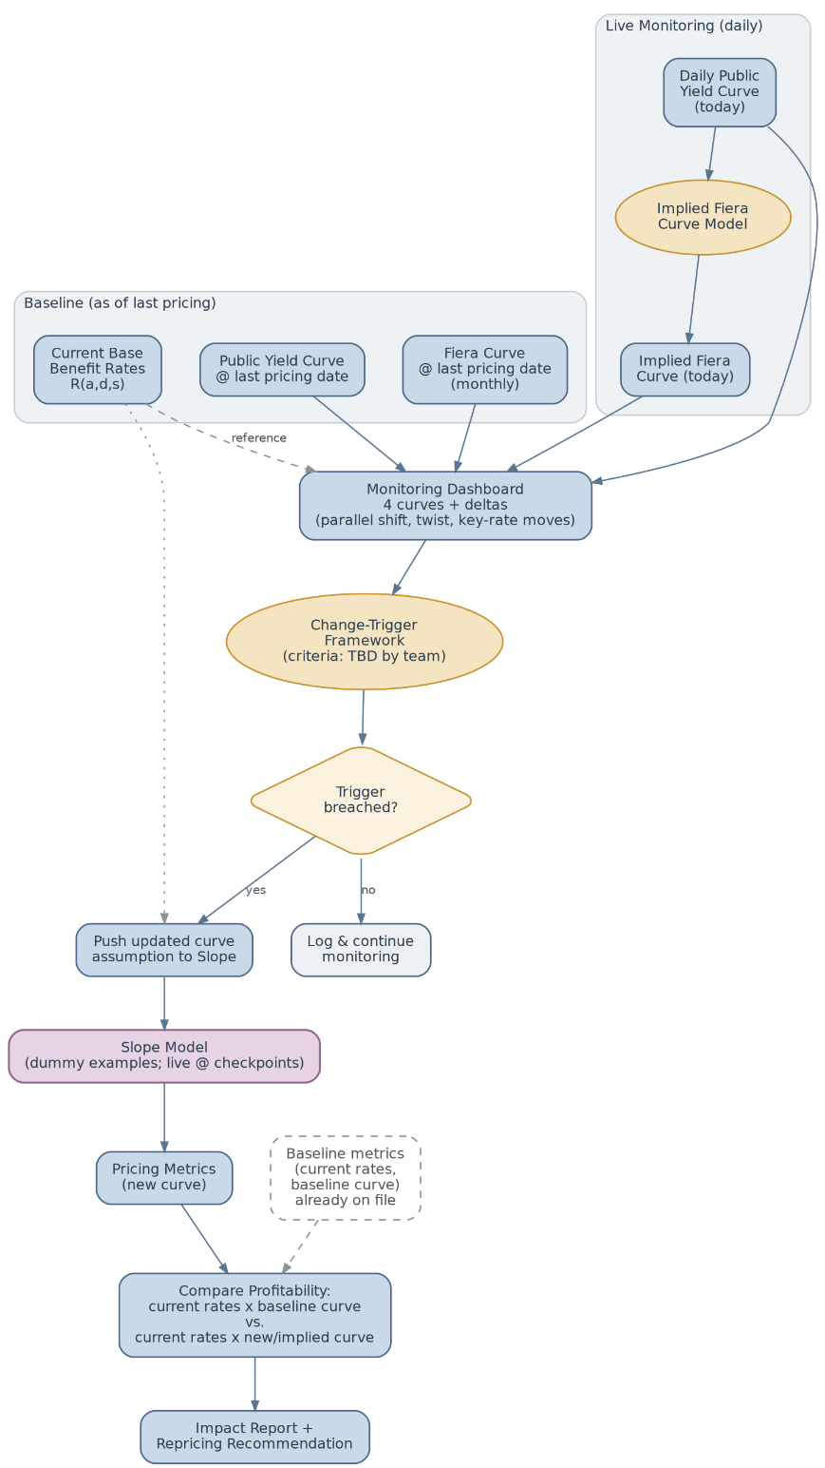
5. Key Tasks

A. Data sourcing & ingestion
- Evaluate candidate daily Canadian yield curve sources; document coverage and methodology for each. Provide a recommendation for the source of daily yield curves. Students are not expected to pay for access to a source. If you can find a free trial for your recommendation, please go ahead and use that. If not, provide your recommendation to us by Oct. 9, 2026. We will consider the recommendations of each group, choose the source that fits our needs best, and provide access to data from this source.
- Build a Python pipeline to pull, clean, and store the chosen curve(s) historically and going forward.
- Source and store historical monthly Fiera curve snapshots for back-testing and audit purposes.

B. Monitoring dashboard
- Display: the yield curve from the pricing and current bases, and the pricing and implied interest rate curves (based on current yield curve).
- Output: Curve deltas in actuarially meaningful terms (e.g., parallel shift, twist), not just raw plots.
- Status: (e.g., TRIGGERED)

C. Change-trigger framework
- Propose one or more candidate definitions of “needs a change,” each with a stated rationale.
- Test candidates against historical curve data: how often would each have fired, and does that frequency seem reasonable?
- Recommend one, with its trade-offs made explicit.

D. Profitability & reporting
- Build the Slope integration that runs current benefit rates under the baseline curve and under the new/implied curve. You will develop against the dummy Slope implementation and we will run it against the real model at checkpoints. We currently export several tables of data from a Slope run, then copy those into an Excel workbook to compute profitability metrics. Make this process more efficient by directly computing the profitability metrics in Python and outputting them in an easy-to-read format.
- Package the methodology, dashboard, and findings into a report and presentation.

6. Deliverables
- A working Python codebase: data pipeline, the Fiera curve treatment you recommend, exported results handling, and profitability metric computation.
- The monitoring dashboard (static or interactive).
- Written report, Times New Roman 12pt, single-spaced, 1" margins, maximum 10 pages of body text (exhibits, tables, and figures are included in the page count, but appendices are excluded). The report must contain:
  - (i) a memo defining and justifying the proposed change-trigger criteria;
  - (ii) a profitability comparison: current benefit rates under the baseline curves vs. under the new/implied curves.
  - (iii) an operational process document (i.e., how will this work in practice?)
- A final presentation to TVFI with a recommendation.

7. Resources

We have provided links to helpful resources and documentation below:

Slope API documentation

Automation script example snippets that use the API

Fiera curves

We will also provide you with the dummy Slope implementation and more details about our methodology for computing profitability metrics.

8. Contact Info

Please email questions/requests to both Sam Guan (sam.guan@tvfi.ca) and Nathan Phelps (nathan.phelps@tvfi.ca).

